Jenkins server setup:

1.set ubuntu server

2.apt update -y

3.apt install openjdk-11-jdk -y

4.

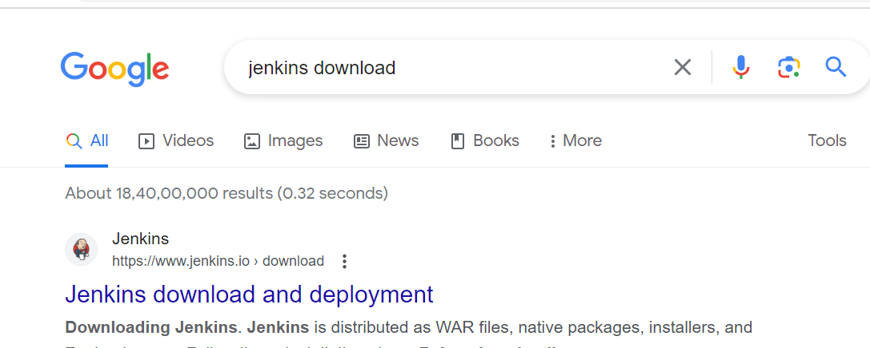

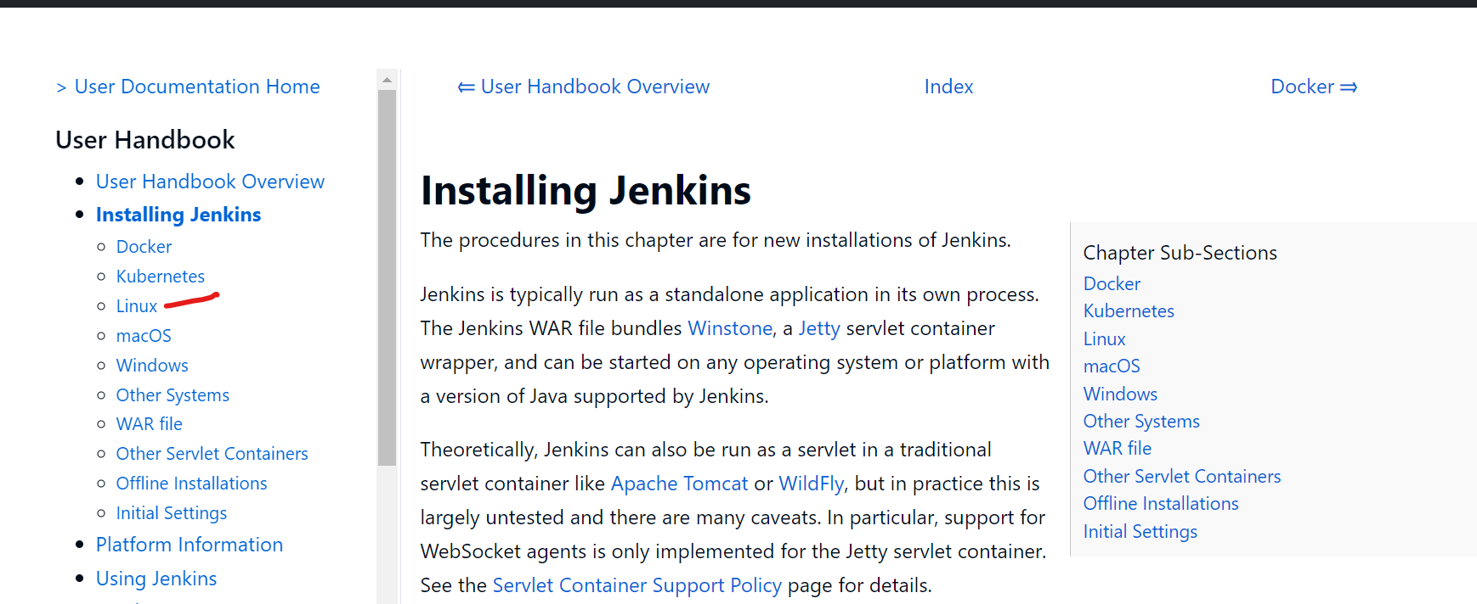

<https://www.jenkins.io/doc/book/installing/linux/#debianubuntu>

curl -fsSL https://pkg.jenkins.io/debian-stable/jenkins.io-2023.key | sudo tee \

/usr/share/keyrings/jenkins-keyring.asc > /dev/null

echo deb [signed-by=/usr/share/keyrings/jenkins-keyring.asc] \

https://pkg.jenkins.io/debian-stable binary/ | sudo tee \

/etc/apt/sources.list.d/jenkins.list > /dev/null

sudo apt-get update

sudo apt-get install Jenkins

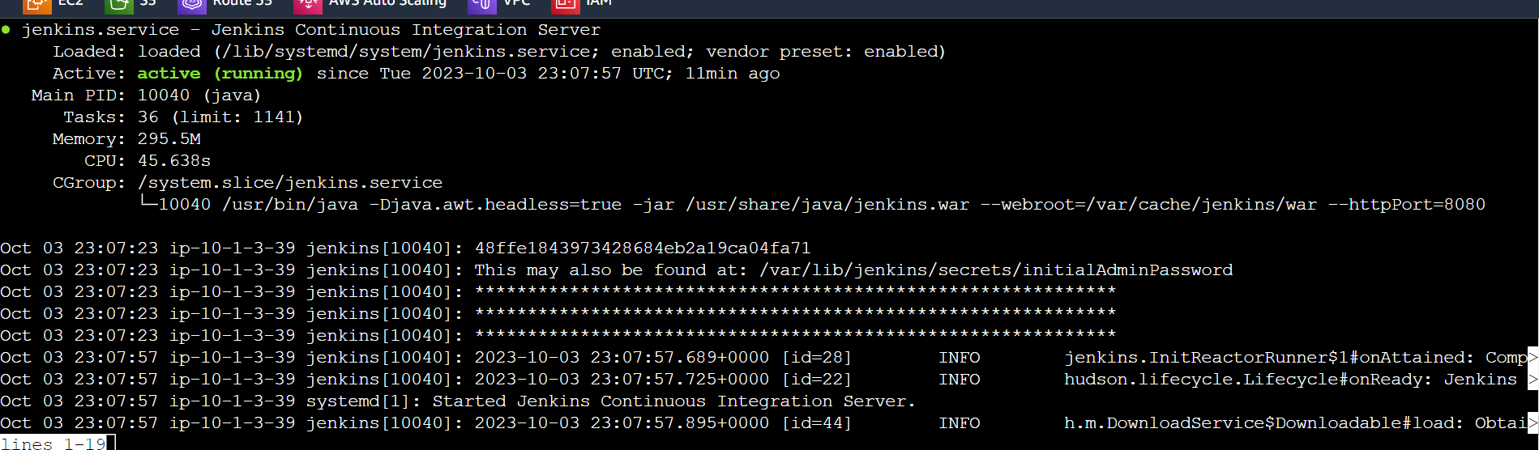

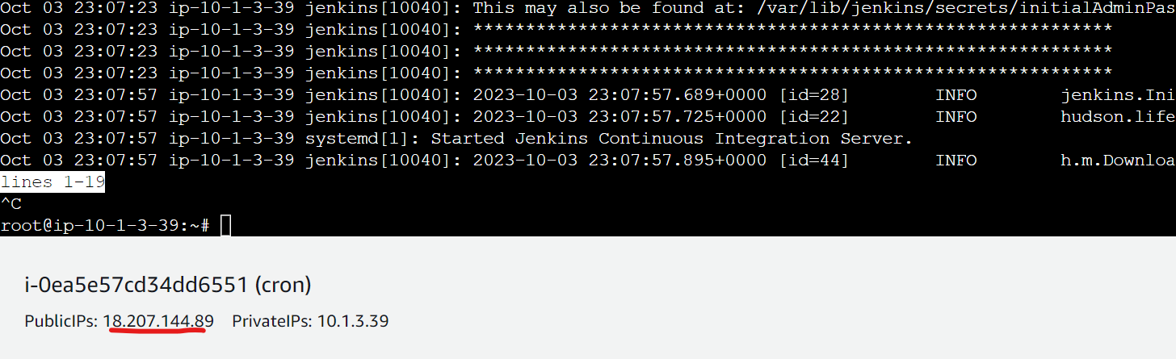

Copy public ip: 8080 gogle it new tab

18.207.144.89:8080

Output:

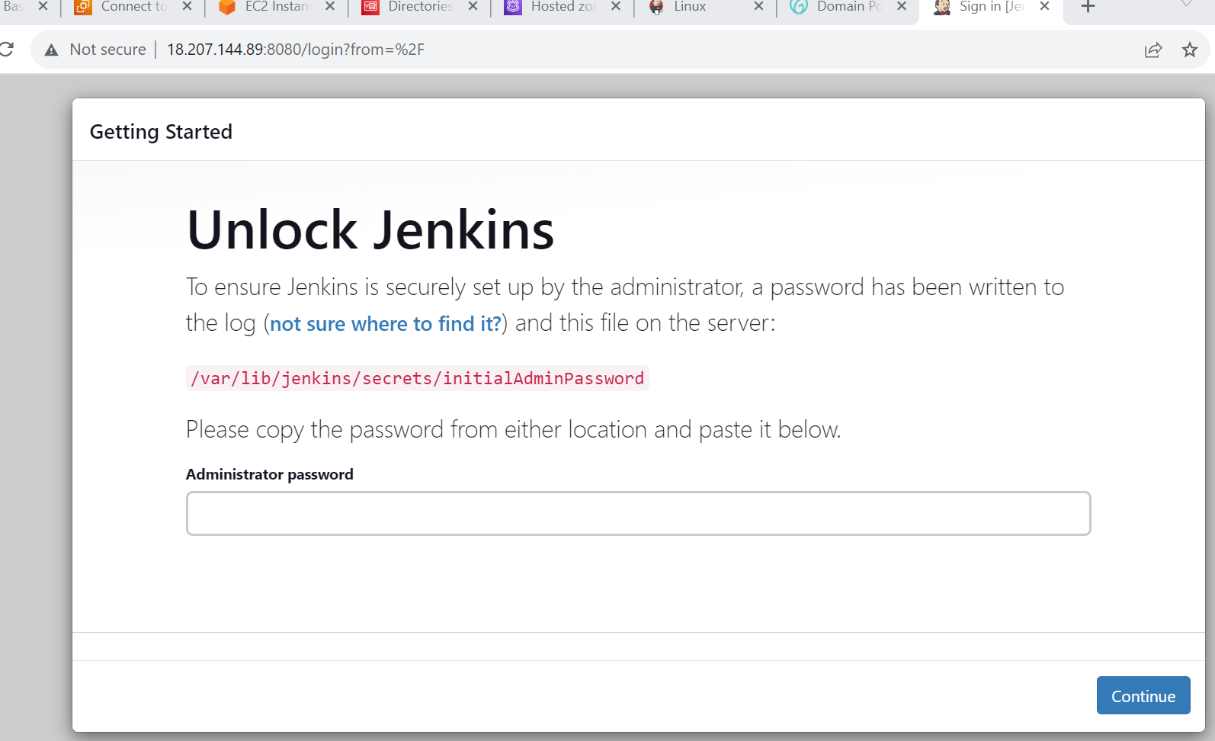

Copy 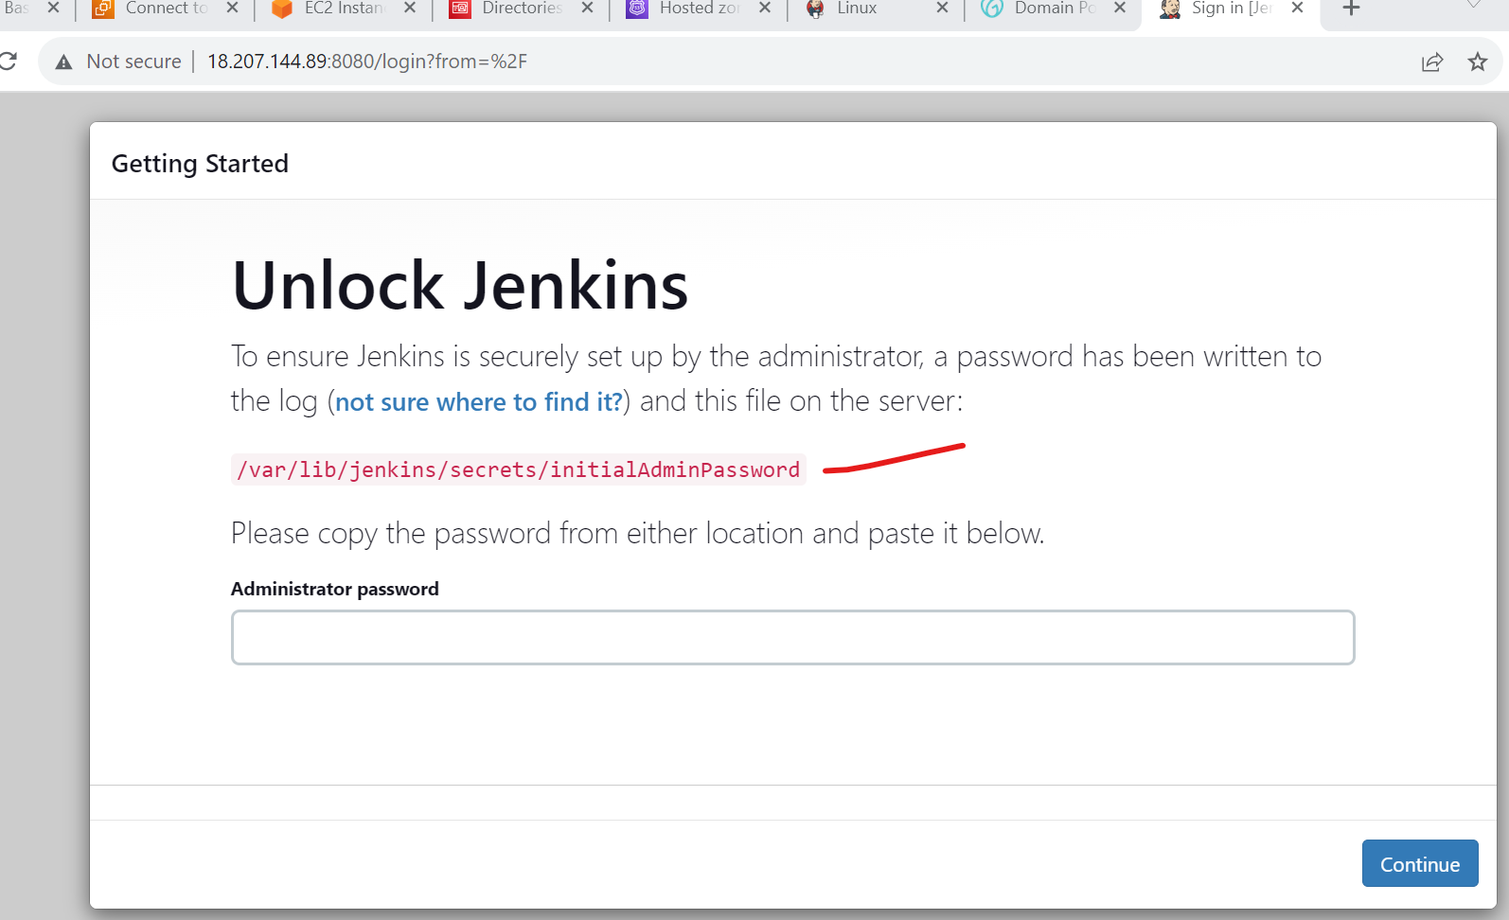

Then cat



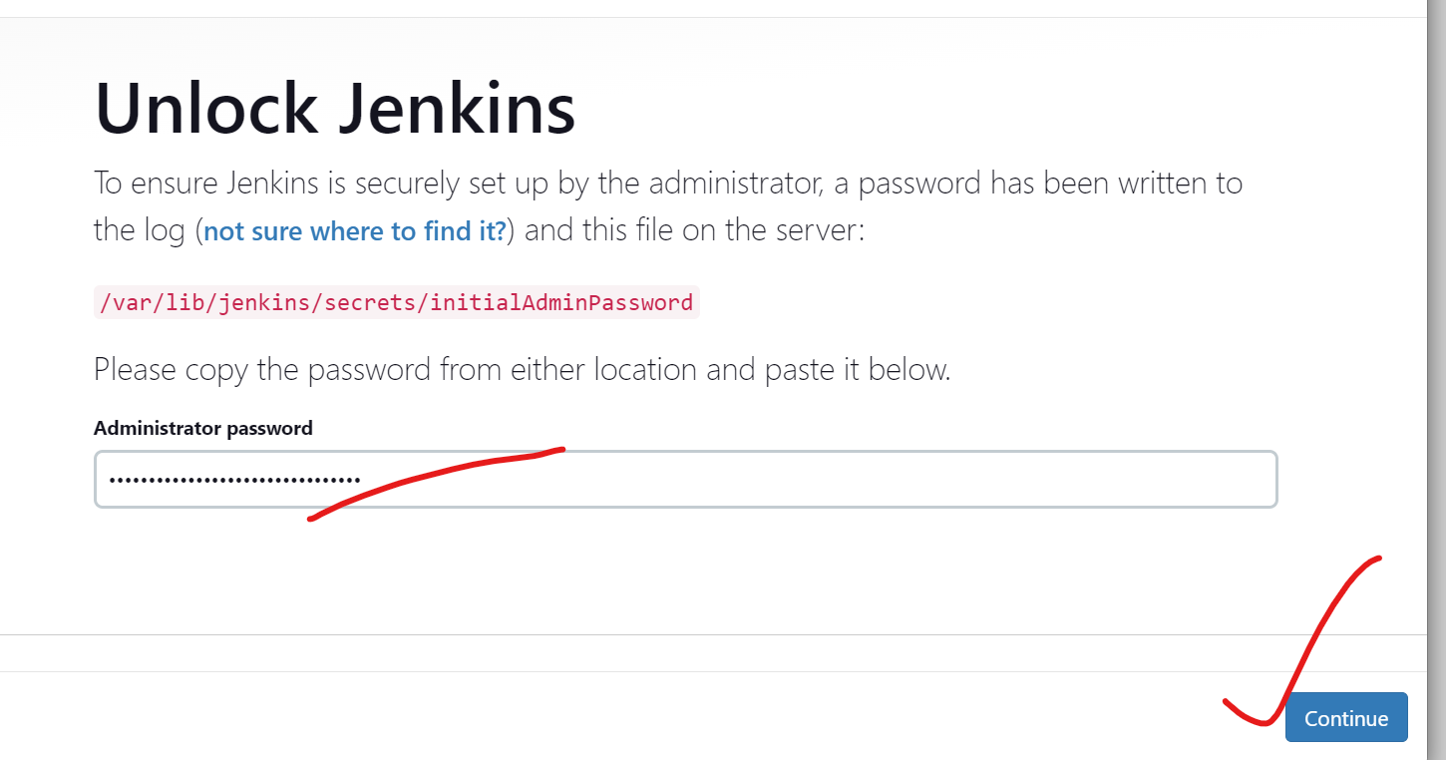

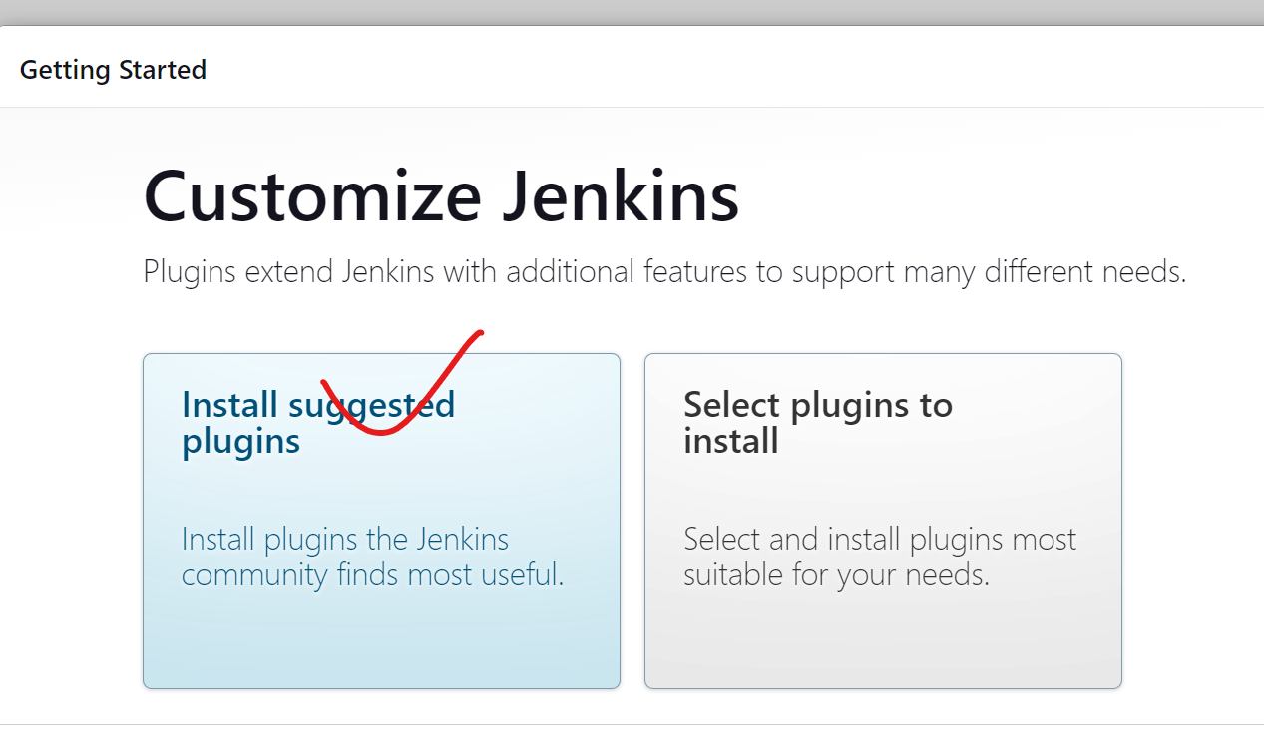

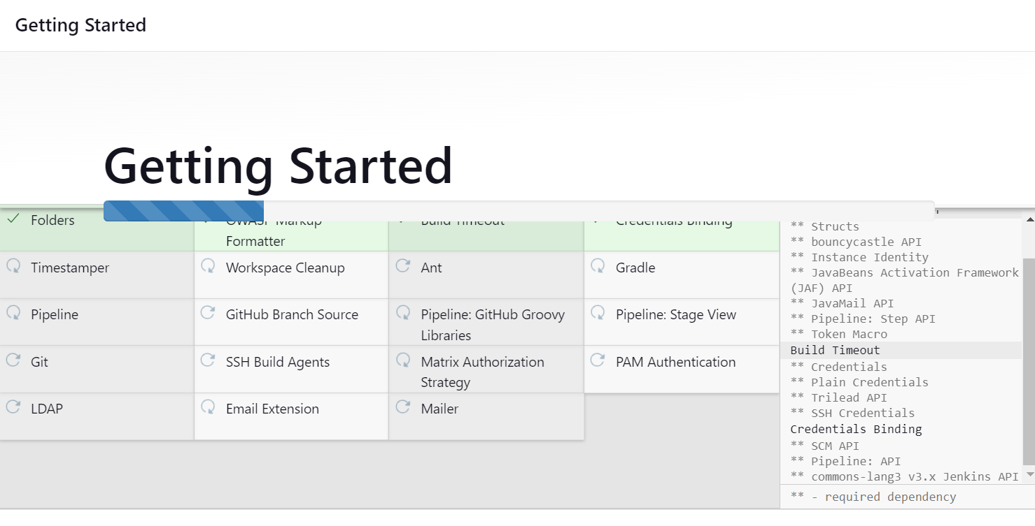

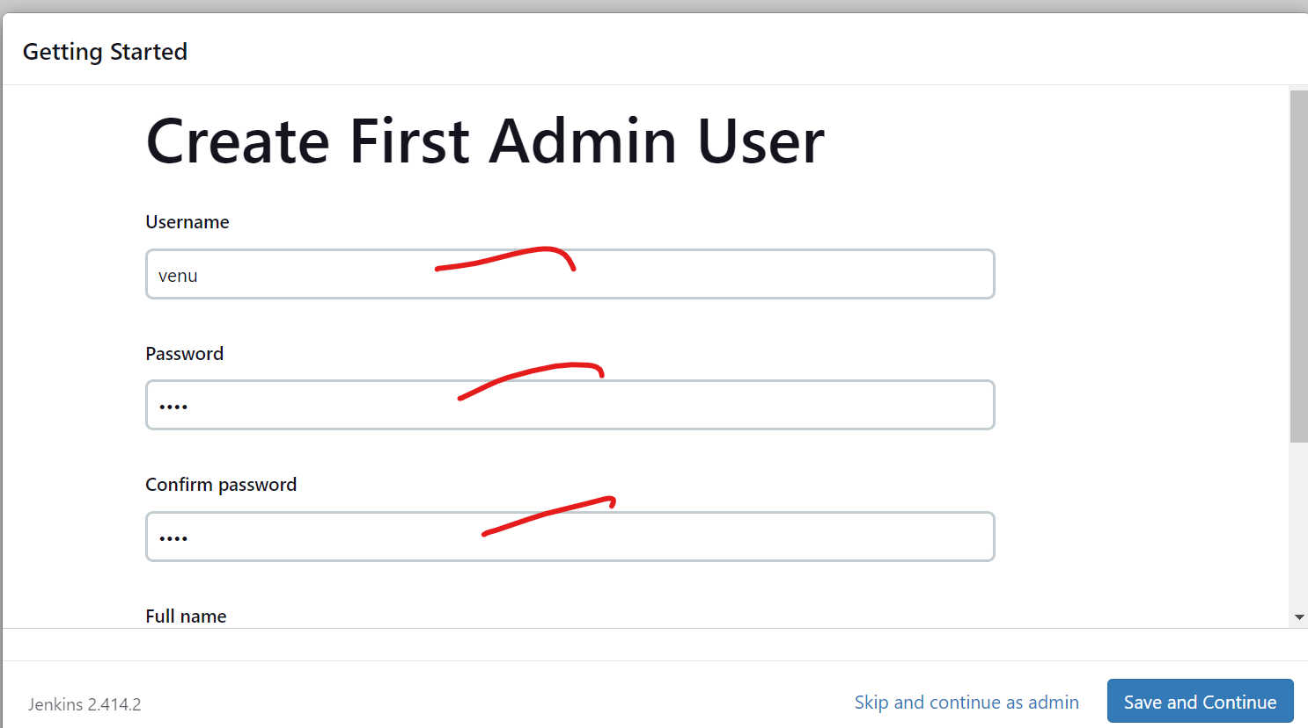

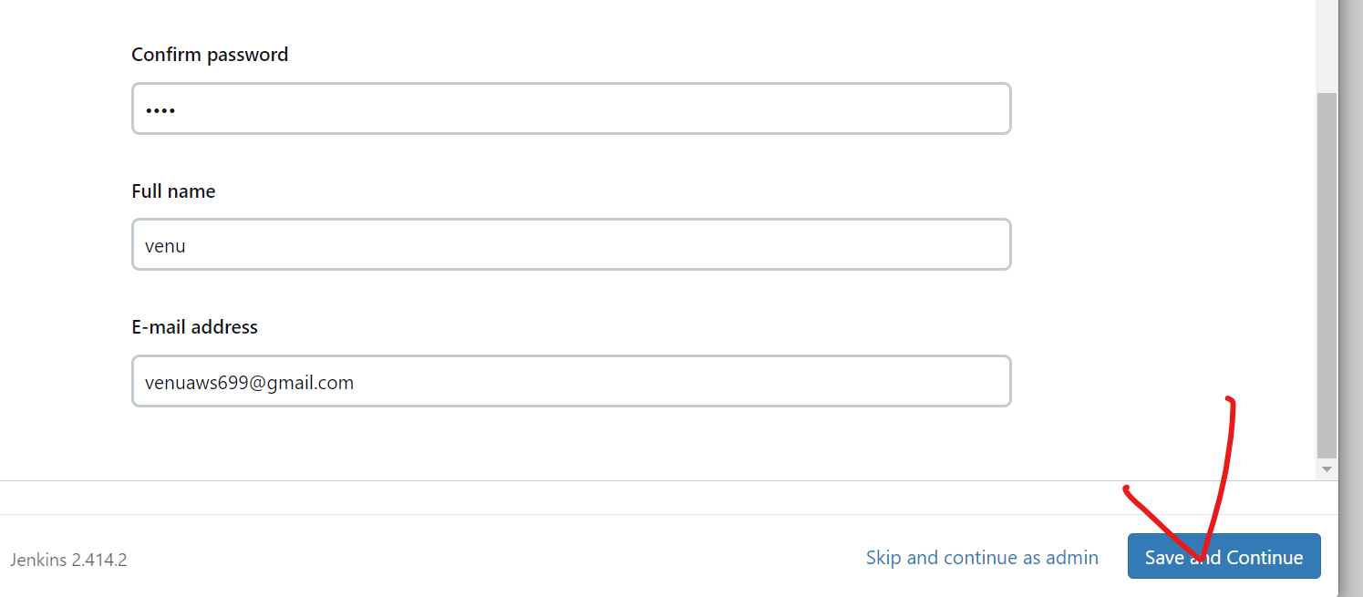

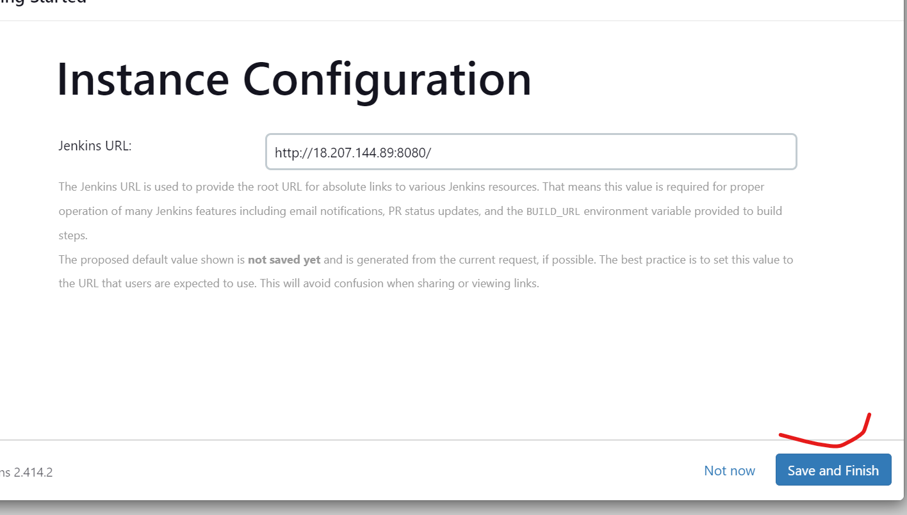

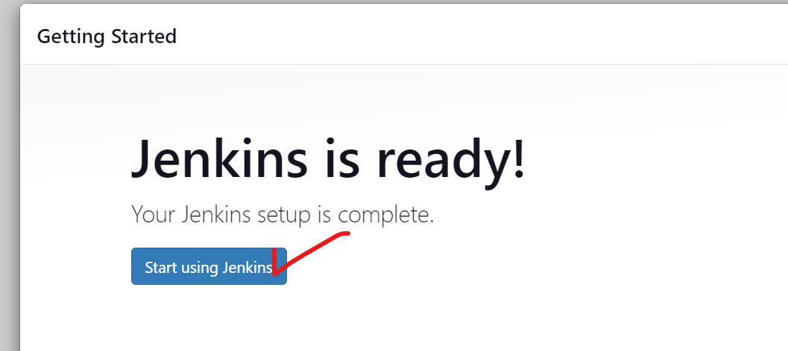

Select new item:

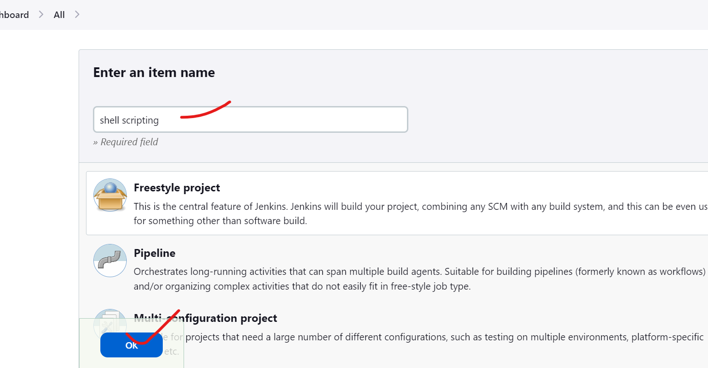

**#!/bin/bash**

**for** i **in** 1 2 3 4 5

**do**

   echo "Welcome $i times"

**done**

copy and paste in shell

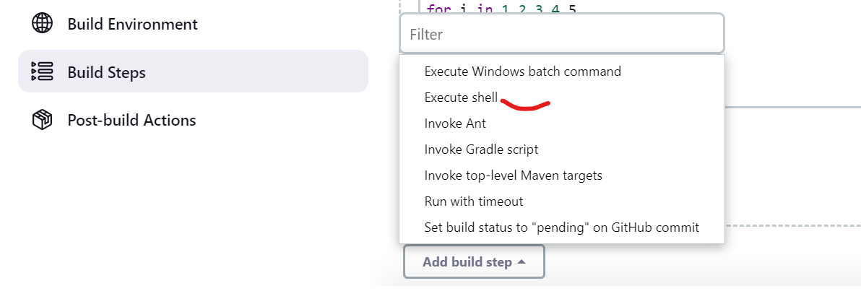

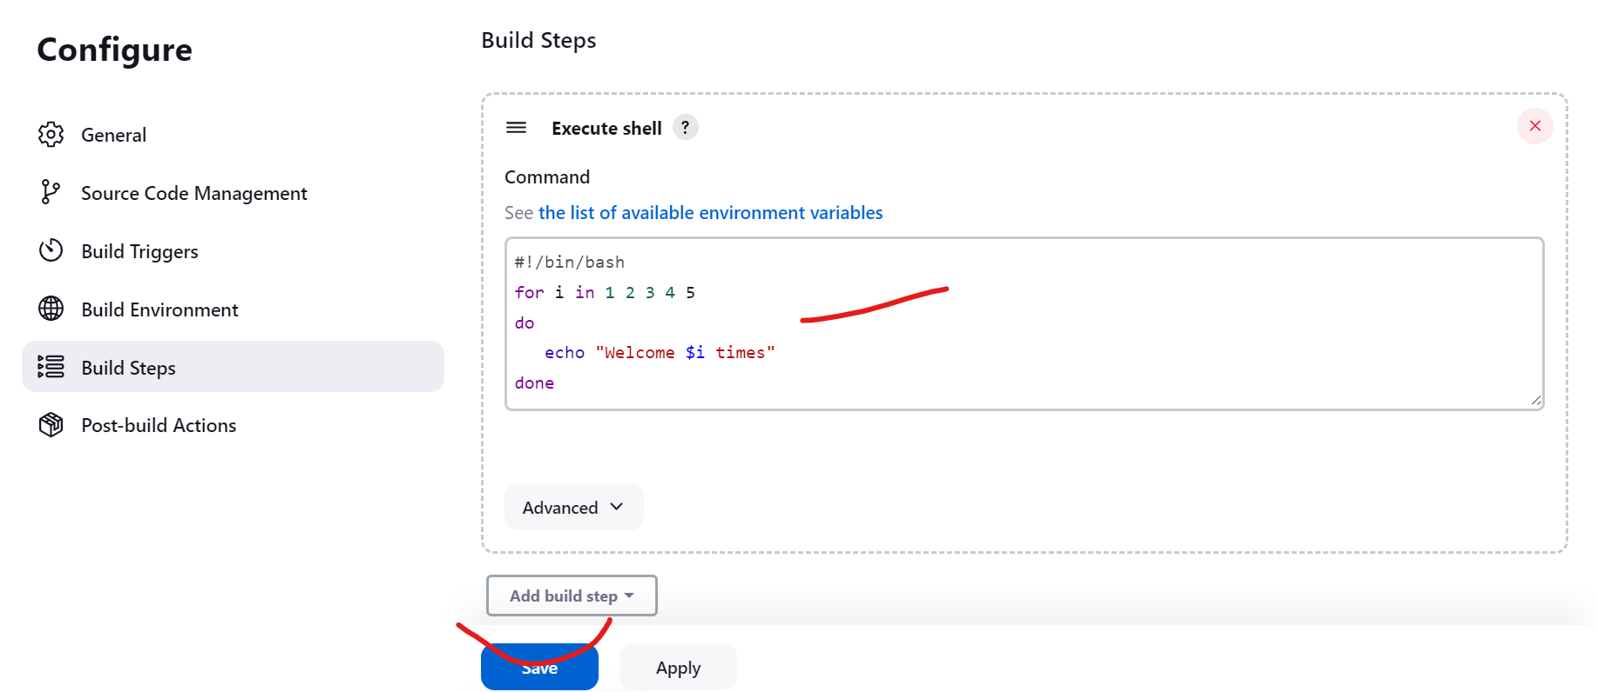

Save it

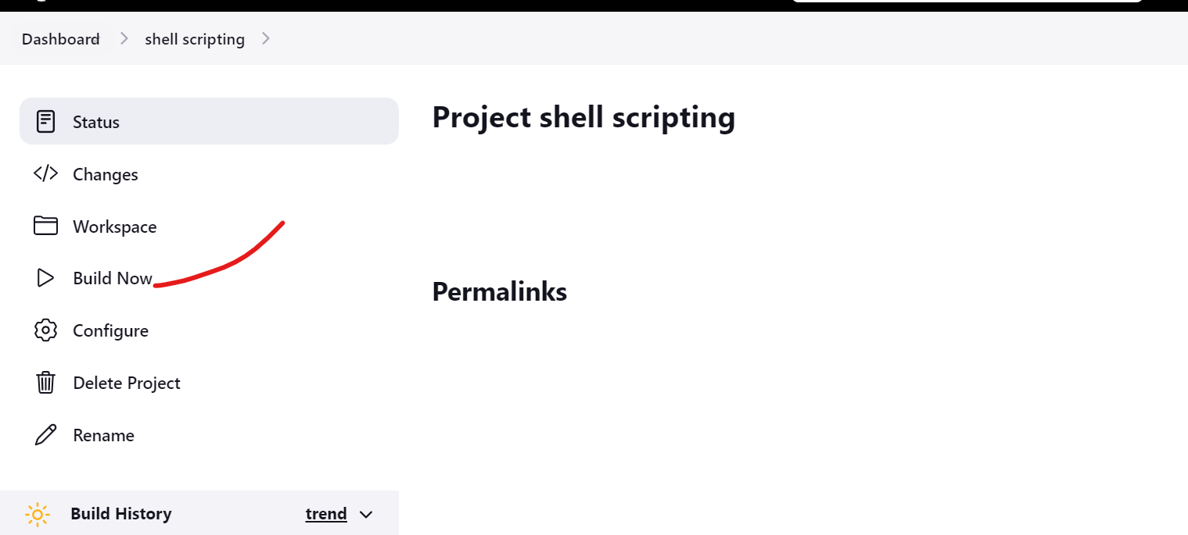

Build now

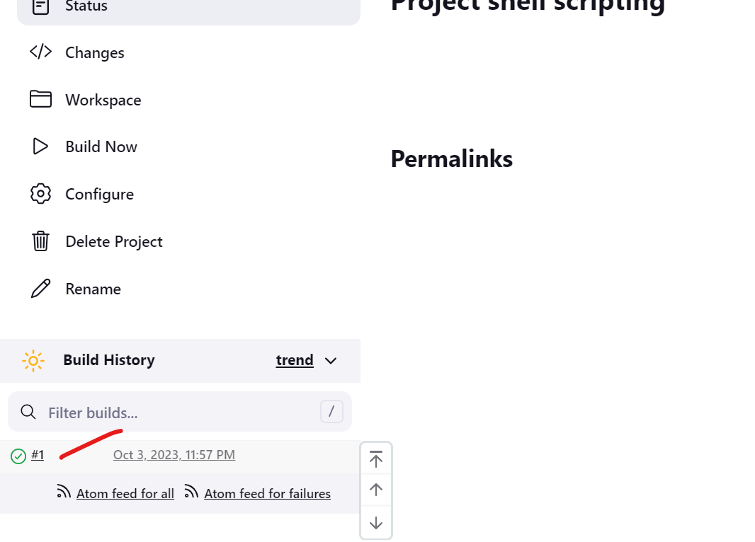

Check console output

